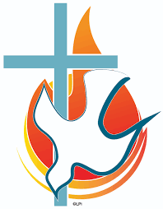
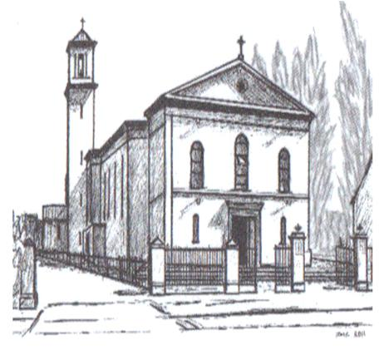
Church of ‘Our Lady Help of Christians’

NAVAN ROAD PARISH, DUBLIN 7
Registration Form for The Sacrament
Of Confirmation 2024

Information is for Parish Sacramental Preparation and will not be disclosed to any third party All information will be deleted from Parish records after the Ceremonies. Confirmation record will be entered on the parish register

Child’s Name First
Names and Surname
AS ON BIRTH CERT

Child’s Date of Birth

Child’s School
Please tick

CHILD’S CLASS
Please tick under
Teacher’s Name

PARENTS / GUARDIAN
Names in BLOCK
CAPITALS

SIGNATURES

ADDRESS

MOBILE NO.S

EMAIL ADDRESSES

s

Mary Help of Christians  Girls National School | Saint John Bosco’s Senior  Boys National School
Ms. Carr | Ms. Hannon | Mr. Deegan | Mr. Harris | Ms. Ryan
Please provide a copy of Baptismal Certificate certificate
Date First Holy Communion Received

Month | Year
Parent 1 Parent 2 (Optional)
Parent 1 Parent 2

Please provide a copy of child’s Baptismal Certificate (Catholic) ☐

Your €10 contribution towards Sacramental preparation expenses. ☐
(If paid online through www.navanroadparish.com please enter receipt no.__________________

The Family Mass team will be asking for participation in some Preparation Masses & in the Parish Preparation Programme

Would your child like to be considered for……….

Reading Prayers of the Faithful. ☐

Bringing the Gifts to the Altar. ☐

Reading: Welcome or
After Communion Reflection ☐

Would you as a parent consider…….

Reading at The Liturgy of the Word ☐

Helping with the Parish Preparation Programme ☐

Helping the Family Mass Team ☐
(To prepare the liturgy for ceremonies)

Email: nrfamilymass@gmail.com for information on Family Mass

